Bang Huong Dan
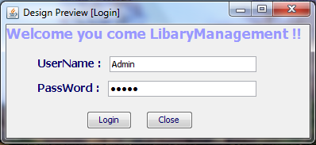
- You must input UserName and Password, after click Button_Login.(Login system)
- If you don’t want to use system, you can click Button_close (out system).
- If you are admin. You can use:
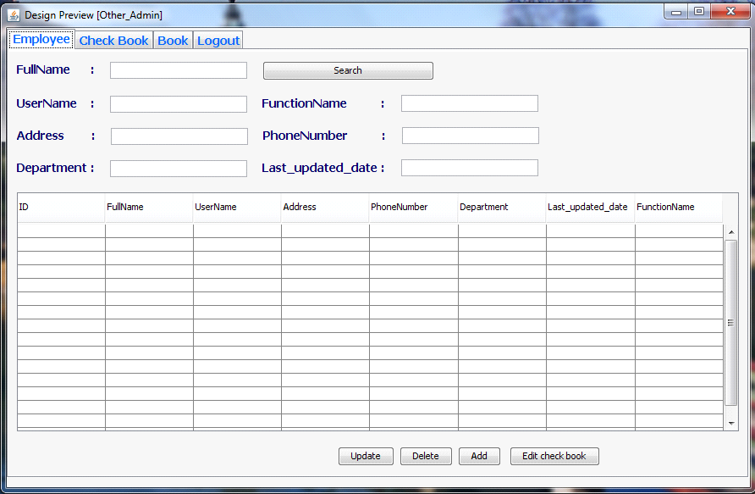
Admin:
- Admin can view information of Admin and Employee.
- Admin input FullName of LibraryManagement and Employee, after click Button_search(search information admin need).
- Admin can edit information of Admin and Employee, after click Button_update (update data).
- Admin can delete Employee is searched.
- If Admin want add a Employee, admin input all information on the Textfield, after click Button_add(add data).

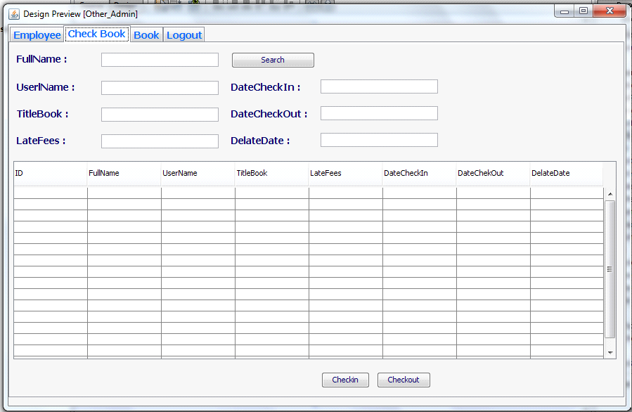
- Admin can view all list of Employee checkout book.
- Admin input FullName of Employee need checkout book and checkin book, after click Button_search(Search information need checkout).
- After search Name of Employee need checkout book, admin can edit information Datecheckout and Datecheckin book, after click Button_checkout(For Employee checkout).
- When Employee checkin book, admin click Button_checkin.

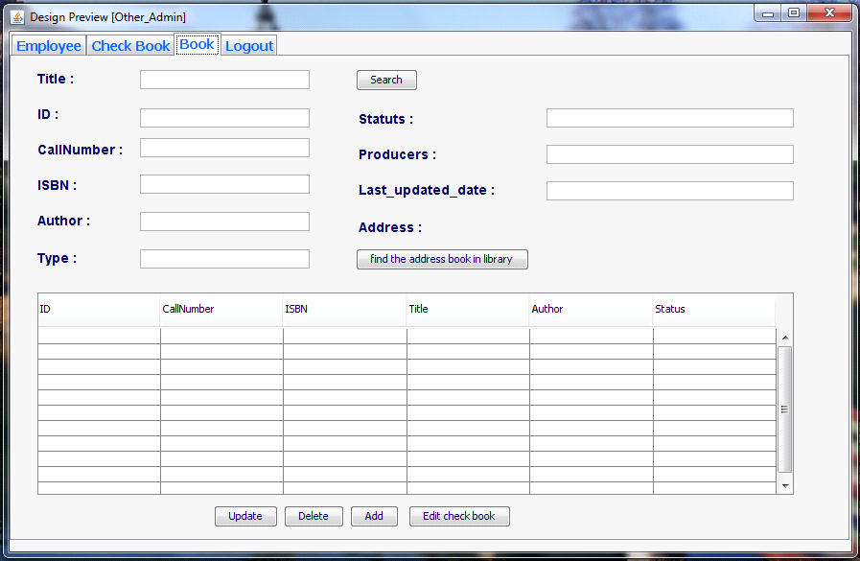
- Admin can view all list of book.
- If admin want find a book. Admin must input titlebook. after click Button_search (Search information book equals titlebook).
- If admin want find position book. After click Button_find the address book in library.
- Admin can edit information book. after click Button_update(update data book).
- Admin can delete book is searched.
- If Admin want add a Book, admin input all information on the Textfield, after click Button_add(add data).

LibraryManagement:
The action in system library of Librarymanagement like admin.

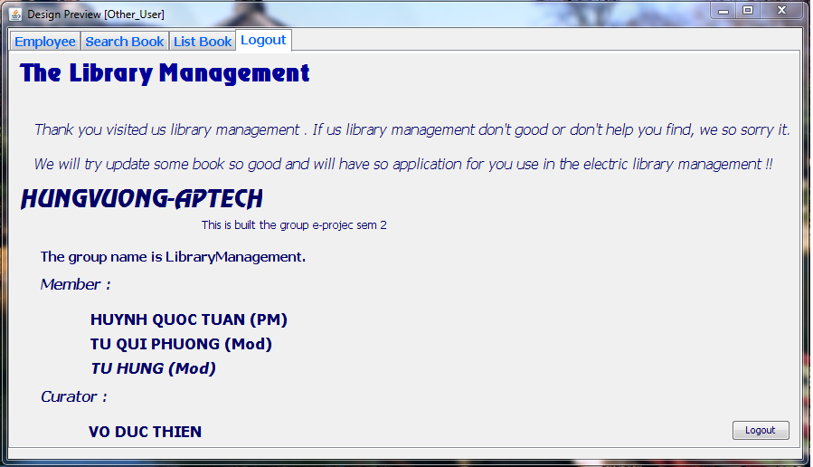

If Admin and LibraryManagement didn’t use system. Admin and LibraryManagement can click Button_logout.(Exit System).

Employee:
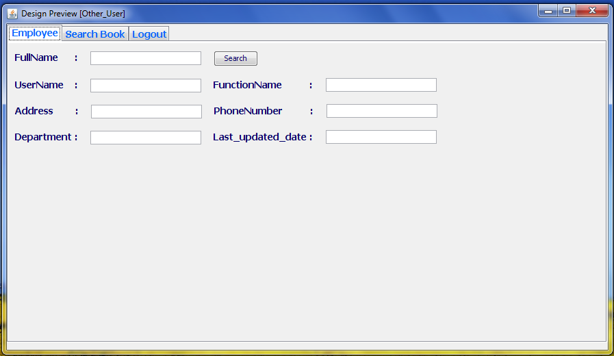
- Employee can view information of Employee.

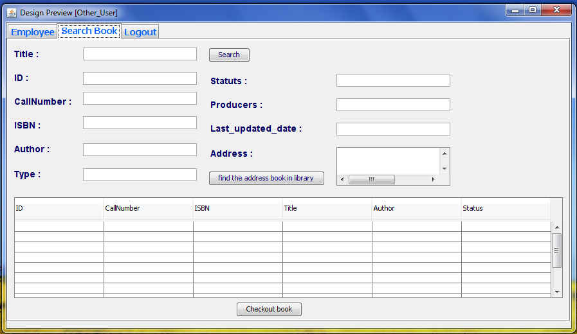
- Employee can view all information book.
- If Employee want find a book. Employee must input titlebook. after click Button_search (Search information book equals titlebook).
- If Employee want find position book. After click Button_find the address book in library.
- If Employee want checkout book. Employee search information book need checkout. after click Button_checkout.

